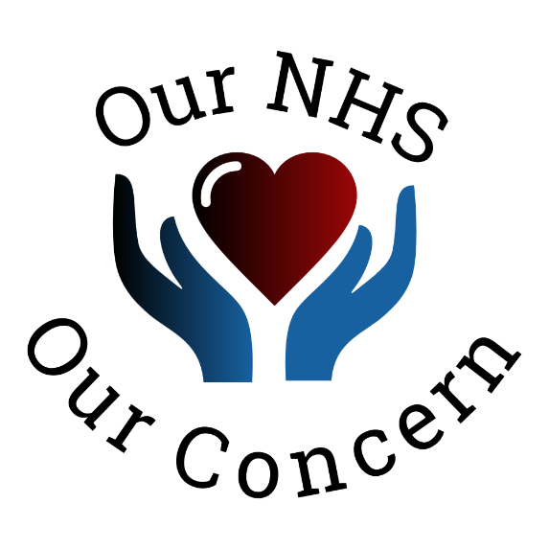

Changing the Narrative: What staff think of Efficiency and Improvement in NHS Funded Services
Report by Christine Perry, Policy Director – May 2020

1. Why and How we Carried out this Survey
We carried out a survey to find out the views of frontline staff as to the efficiency of NHS funded services and their ability to make improvements. We did this because we had anecdotal evidence that frontline staff felt the services they worked in were inefficient and that their attempts to make improvements were often not supported and frequently stopped. We wanted to find out the extent to which this was happening in NHS funded services and to help us in taking forwards themes and ideas for Our NHS Our Concern Think Tank members to address.
Survey Monkey was used for design and analysis of the survey, which was then distributed through social media e.g. Twitter, Facebook. The respondents to the survey self-selected and we did not ask for role or location of where the respondents worked.
This report summarises what 100 of the respondents told us.

2. What Staff think of Efficiency and Improvements

Efficiency of Organisations
We asked – How efficient is your organization in using NHS Funds?
Seventy percent of respondents felt their organisation was either inefficient or very inefficient in the use of NHS Funds. This is particularly concerning given the financial deficit position of many NHS organisations even before the COVID-19 crisis. There is a clear message that NHS funded organisations can do more to improve their efficiency by listening to where staff see inefficiencies in current services.

Comments that survey respondents made in this area include:
“We all need to reflect on our efficiency as well”
“We are made inefficient due to lack of resources”

We asked – How much Waste do you see in some Key Areas?
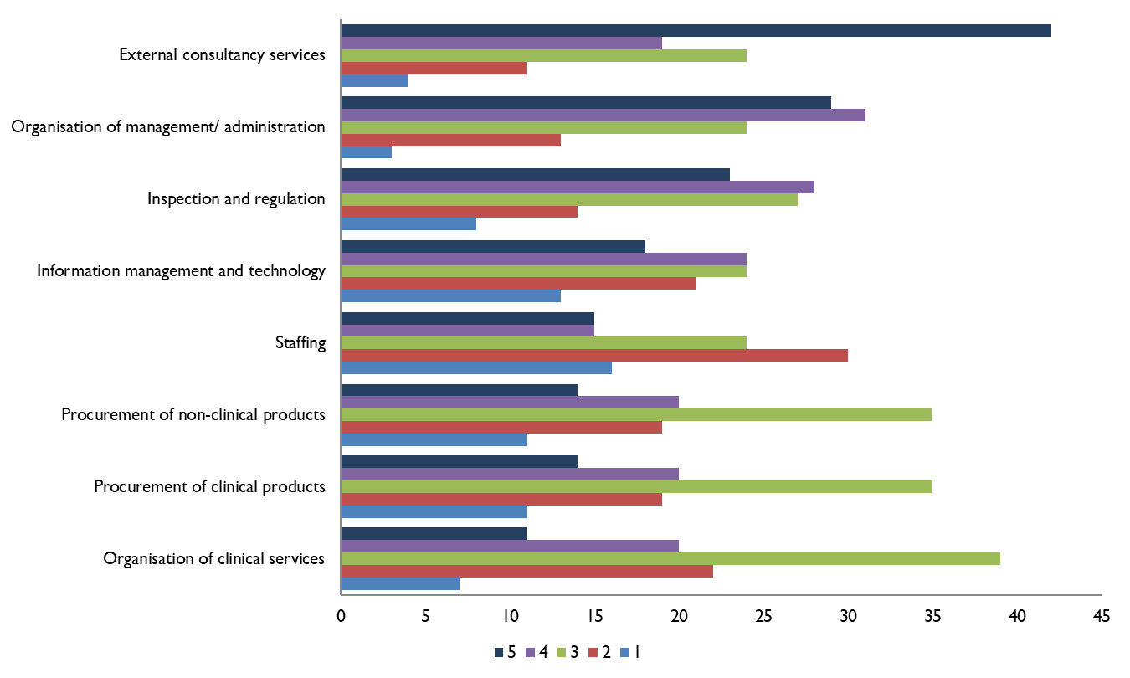
The three areas where staff saw most wastage were: External Consultancy Services; Organisation of Management/Administration; and Inspection and Regulation. Almost half of the respondents ranked the use of External Consultants as the highest level of waste. This suggests that front line staff do not see any benefit from Consultancy services in making improvements. The low level of waste seen in organisation of clinical services suggests that efficiency is greater at the front line than is seen further away from front line services.
Comments that survey respondents made in this area include:
“Monitoring the quality of care is important but not spending billions on CQC, NHSE and other NHS related organisations”
“If you can work on reducing red tape, bureaucracy and make CQC more realistic that would be a good start”

Our NHS Our Concern Areas for Focus
We asked – Which of the Areas of Waste do you see as High Priority for Our NHS Our Concern to Address?
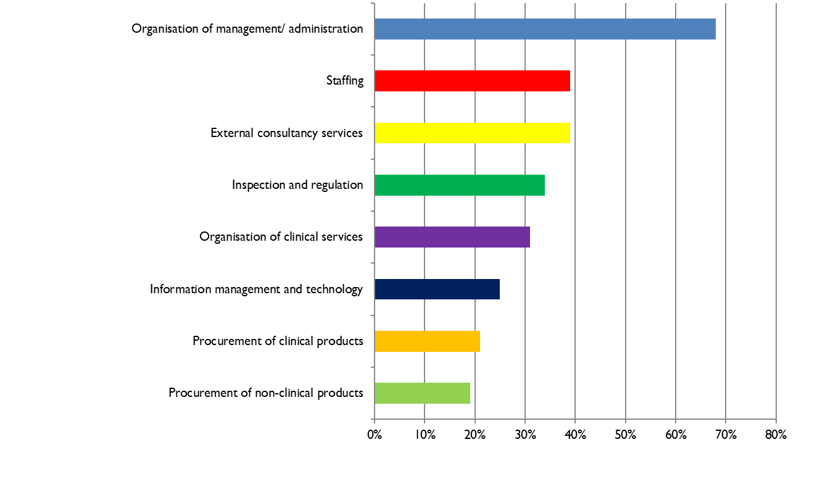
Although External Consultancy was seen as being most wasteful, the highest priority for Our NHS Our Concern was Organisation of Management/ Administration.
Comments that survey respondents made in this area include:

“NHS needs to be clinically led and managerially supported, not managerially led and clinically supported”
“Too many layers of middle management in NHS. This is an absolute waste of resources that could be well diverted to front line clinical services”
“The administration should take the time and effort to talk to majority of staff and to try to address their concerns. This will help to improve NHS”
“I am not sure if bringing in ‘managers’ and ‘failing clinicians/nurses’ to an administrative role is helpful in any efficiency or cost saving”
“Engage clinicians more in management decisions, ensure optimal triumvirate working (medical/clinical, nursing, management/secretarial working synergistically together)”

Suggesting and Implementing Improvements
We asked – How easy is it for you to suggest and implement improvements in efficiency?
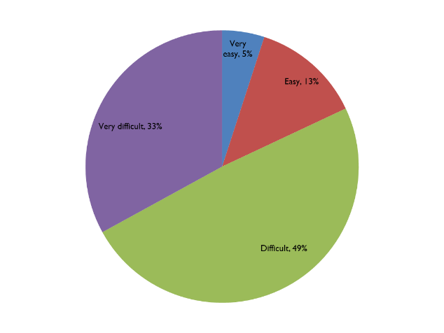
Staff often have suggestions for improvements and solutions to frontline problems. It is very concerning that 82% of survey respondents find it difficult or very difficult to suggest and implement efficiency improvements.
Improvements can be very effective when led and delivered by frontline clinical staff e.g. the shift to day surgery, new imaging techniques, remote consultations via telemedicine. There is a need for NHS funded services to engage frontline staff at the start of their annual planning for efficiencies, as well as having a process for listening and acting on staff improvement suggestions on an ongoing basis.
Comments that survey respondents made in this area include:
“Creating a stable and supportive work environment by management for health professional is a must, as then only they will work proactively for better health of organization”
“Invest in useful areas”

Wastage and Further Funding
We asked – Do you agree that wastage should be reduced before more funding is allocated to the NHS?
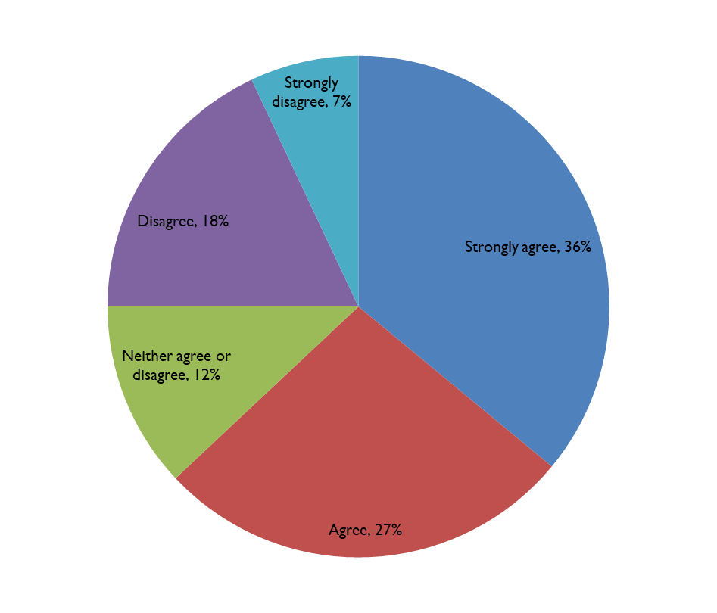
There is a surprisingly high proportion of staff that think waste reduction should come before further funding with 63% agreeing or strongly agreeing. Frontline staff clearly see NHS funds being wasted whilst there is a perception that the NHS is chronically underfunded.
If NHS Leaders engaged fully with frontline staff, they are likely to receive good support for efficiency improvement programmes that frontline staff can identify with.
Only a quarter of staff disagreed and would wish to see more funding before addressing existing waste.
“Wastage has to be dealt with. However increased funding cannot wait because we deal with peoples lives”
“Take NHS away from politicians -managed by clinical/management experts with guaranteed ring-fenced funding linked to inflation as a proportion of GDP”
“NHS waste reduction programme is operational in our department”

4. Next Steps for Our NHS Our Concern
Our NHS Our Concern has developed a Think Tank that is different in that its members are highly respected frontline staff with extensive clinical and managerial expertise. The Think Tank members are creating reports that are focused on solutions to some key areas where efficiency is needed. We will use the results of this survey and comments provided by the survey respondents to inform the solutions put forwards by the Think Tanks.

We would like to thank all those staff who took the time to respond to our survey.

About Our NHS Our Concern

‘’Our NHS Our Concern’’ is a think tank which offers a new narrative for the NHS by embracing practical, innovative and cost-neutral solutions to the current crisis in morale, healthcare provision and the dominant ethos.
Our values are the founding principles of the NHS: care free at the point of need, available to all, and a great duty of state, where the measure of success is health or living well with a long-term condition.
Our mission is to reduce need and develop and promote efficiencies in the organisation and delivery of UK healthcare.
Our vision is an efficient, effective, equitable NHS.
Our NHS Our Concern is offering a different narrative based on proposing solutions involving front line staff and aimed at avoiding wastage which remains a huge problem in the NHS.
Our aim is to provide quality care within finite resources, minimising the need for more staff.
We are promoting a new narrative towards a change in culture, which promotes the role of frontline staff in generating ideas and driving actions.
www.ournhsourconcern.org

